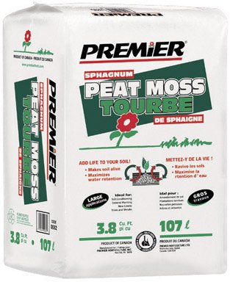

Sphagnum Peat
Moss
- 2.2 Cubic Feet
- Maximizes water retention
#30
- Makes soil alive

$9.99
70585

